Shoreham Village Senior Citizen Association

Update on Strategic Priorities

CEO Report to the Board of Directors
November 17, 2021

I hereby confirm that all statutory withholdings and remittances relating to the organization’s employees or otherwise have been made.

Strategic Priority: Achieving Accreditation by 2023

Our survey visit is now tentatively scheduled for June 2023.

On November 10, 2021, Accreditation Canada hosted a webinar to introduce organizations to their new Qglobal program/continuous assessment model. There continues to be some delays in the roll out of OnboardQI, which is their new online platform used to support our assessment activities, as well as collaborative action planning tools. Current projections are the end of November for the roll out of this platform.

Creating and sustaining a caring culture

- Services are delivered and decisions made according to the organization’s values

- A healthy and safe work environment and positive quality work life are promoted and supported

- A quality improvement culture is promoted throughout the organization

OT/PT resources: As previously reported, we have been provided additional funding in the following areas:

- Occupational Therapist: from 0.20 to 0.60 FTE
- Physiotherapist: from 0.24 to 0.60
- Rehabilitation Assistant: from 1.00 to 1.20

The new OT is in place. We are reposting for the PT position and Rehab Assistant.

Grant applications:
- We have been successful in attaining a $1000 grant from The Community Development and Recreation Committee, Municipality of Chester for Yoga and Meditation grant.
- We have submitted an application to the Community Health Board for support for a Cooking Class.

Scorecard/Transparency: We have begun posting 2 key indicators (hand hygiene and incidents) results on our website

Continuing Care Month: Harding Medical donated 5, $10 gift cards in a phone holder. We held a draw for all 5 to kick off CC month.

Planning and designing services

- Services are planned and designed to meet the needs of the community
- The changing needs and health status of the community served are understood
- Operational plans are developed and implemented to achieve the strategic plan, goals and objectives
- The organization’s leaders collaborate with a broad network of stakeholders

Garden Project: We have been advised that we were not successful in the funding application made to the Healthy Communities Initiative Grant. We have advised the Apartment Board of this outcome and have asked their interest to look at a phased in approach to achieving the vision for the project. They are keen to continue. As reported in the financial report, we are in a surplus position, primarily due to staff shortages unfortunately. Unfortunately, as noted, we do not see that trend turning around quickly. We would like to recommend that the Board consider allocating a sum of money- up to $20,000 so we can begin implementing our phased in approach to the garden. We would schedule this work to begin in early spring to ensure the expenses are incurred in this fiscal year.

OHC Vaccine fridge: We are partnering with OHC to provide them with vaccine storage in the event of a power outage. We cost shared a new fridge with OHC so that we had adequate space to accommodate the additional storage if required.

Family Council Meeting: Family Council met on October 6, 2021. 11 family members were in attendance; The following items were discussed:
- Overview of new building design
- Ongoing infrastructure improvements
- Q1 Scorecard Overview
- Communications/Newsletter/Facebook/Website
- Influenza season
- Additional staff funding/OT/PT funding
- Electronic Resident File – Electronic Medical File
- Accreditation
- Northwood Shoreham Partnership Evaluation
- COVID-19- Proof of Vaccine Policy, PPE complacency
- Timely meetings/opportunities for family engagement
- Continuing Care Month/Staff Appreciation
- Additional items that arose during the meeting: Comments
- Buzzing in after hours
- The new OT and understand the new role
- CCAs/ working short

Allocating resources and building infrastructure

- The organization’s financial resources are allocated and managed to maximize efficiency and meet the service needs of the community
- The physical environment is safe
- The organization invests in its people and supports their professional development
- Information management policies and systems meet current information needs, take into consideration future information needs, and enhance organizational performance

Capital/Building Improvements/ Funded Project Updates: The waste pipe assessment / repair / epoxy solution project funded by the federal ICIP Program start date is underway. The Resident Room upgrade project was initiated on Oct 25, 2021. Each resident would be out of their room for approximately 2-4 weeks, the full project is expected to go on until May 2022. The team has managed the resident moves very well. We communicated all changes in detail and provided a full overview of the Project at the Family Council meeting on October 6.

DHW Annual Capital Investment Program: We were provided funding to replace our emergency generator and our convection oven. The total amount awarded was $273,000. We have decided not to proceed with the generator project. This issue will be addressed in the facility Renewal project.

Monitoring and improving quality and safety

- There is a process to manage and mitigate risk in the organization
- The organization is prepared for disasters and emergencies
- Resident Safety is monitored and improved on an ongoing basis
- There is a defined quality management system used to assess performance and improve quality

Staffing levels: We continue to invest significant time and energy to address ongoing staffing challenges. The key issue is CCA vacancies which is an industry-wide issue. We continue to work on International Recruitment initiatives. We have established on site accommodations to support staff who are travelling out of the area to work for Shoreham.

Partnership with EMCI: Emergency Medical Care Inc. is developing a program allowing injured paramedics, either physically or psychologically, to re-enter the workforce by volunteering at various organizations within the province. They have approached Shoreham Village as a potential partner for this program. We are currently exploring this opportunity in greater detail. We have one more Long Term Care Aide who is interested in participating in the Northwood Training Program to become an NCA. The previous group of individuals who have participated in this creative approach are doing very well. The goal is to ultimately have these individuals become a CCA.

Recruitment: We participated in an HANS supported recruitment initiative- commercials that began airing during CC month. We are working on a Shoreham Village specific video.

Recognition: Unfortunately, we are not able to plan for our usual Long Service Award /Staff Recognition event. Managers began handing out the Long Service Awards last month.

WCB Rates: Shoreham Village Senior Citizens Assoc. is going from $5.34 in 2021 to $5.48 in 2022. This cost includes the Basic Industry Rate going from $5.98 to $5.97, with a merit of $0.49 deducted from the rate, resulting in the total of $5.48.

Safety Equipment: We have been awarded $8000 for safety equipment. We have submitted our list of priority items for approval.

Electronic Resident File: The electronic Medication record has now been fully implemented.

Client Safety

COVID-19 Update: There remains no new cases of COVID-19 since the outbreak. At the end of September our staff vaccine rate was 90%. Resident vaccination rate was 97% with another resident partially vaccinated and two refusals. We have now begun implementing third doses of the vaccine for residents. We are in the process of finalizing our Proof of Vaccine Program to meet the Nov 30 deadline.

The Continuing Care Branch of the Department of Health and Wellness (DHW) will continue to allocate resources to support Long-Term Care (LTC) service providers for a variety of COVID-19-related expenses. For the next six months, from October 1 – March 31, 2022, DHW will continue providing lump sum payments to support facilities with the costs of Long-Term Care Assistants (LTCA), Infection Control Designates, increased environmental management and general COVID-19-related expenses. Shoreham Village is approved for approximately $180,000.

C-difficile infection: There are no further cases.

Staffing Model: We have received our staffing budget for the renovated building. There are some improvements to our funded staffing levels.

Ceiling lifts: Our new ceiling lifts have been installed but adjustments are required. This remains outstanding. This is impacted by global supply chain issues.

2. Strategic Priority: Facility Renewal Project

On October 21, 2021, we met with the Department of Health and Wellness and the Department of Seniors and Long Term care to review our Step 3 document submission. The various elements of Step 3 include:
- Project Plan
- Functional Program
- Project Budget
- Schedule- We continue to plan for a phased approach to construction and demolition of old resident room wings. At this time the project completion is estimated to be Fall of 2026.
- Risk Management Plan
- Change Management Plan
- Water System Supply Assessment

They have asked us to undergo further investigations re the design being proposed as it relates to infection control. Josie Ryan has taken that feedback back to the architect. They have up to 2 months to review and respond.

Risk Report

Compliance Risk- Contagious Disease Liability Insurance- Pandemic Insurance: As previously communicated, the Ministerial Order has provided a temporary reprieve for the insurance industry Pandemic Exclusion. The insurance renewal date for Shoreham Village was April 2021.
The Health Association of NS (HANS) has been facilitating communication between HOPA and providers and assisting with the collection of the information required by HOPA to evaluate the viability of a group insurance purchase as a member of HOPA for insurance coverage without an infectious disease exclusion, including commercial excess insurance and alternative risk financing options.
The Department of Health and Wellness fully informed of the progress of these discussions. We have been asked to renew our Service contract. The insurance clauses contained are problematic. The Health Association arranged a conversation for the sector to express our concerns. The Department of Seniors and Long Term care have taken the feedback under advisement- we hope to see a new version of the Service Contract soon.

Risk Report Legend:
1. Corporate Risk: Strategic, Compliance, Financial, Operational and/or Reputational Risk
Compliance Risk: The threat posed to an organization’s financial, organizational, or reputational standing resulting from violations of laws, regulations, codes of conduct, or organizational standards of practice (Deloitte, 2015).
Financial Risk: The risk of financial loss to the organization’s ability to earn, raise or access capital, as well as costs associated with its transfer of risk. This includes effectiveness of financial processes for reporting, budgeting, funding allocation and fiscal stewardship (North Simcoe Muskoka LHIN, 2010).
Operational Risk: The risk of direct or indirect loss or inability to provide care services, especially to stakeholders, resulting from inadequate or failed internal processes, people and systems or from external events. Operational risks involve factors such as technical or equipment malfunctions and human error, lack of prioritization, management support or expertise, etc. (North Simcoe Muskoka LHIN, 2010).
Reputational Risk: The risk of significant negative public opinion that results in a critical loss of confidence (patient, staff, physician, family, public). The risk may involve actions that create a lasting negative image of, or loss of confidence in, the overall operations of the organization (North Simcoe Muskoka LHIN, 2010).
Strategic Risk: Risks that affect the entire organization and its long-term objectives and are normally managed by the Board of Directors and Executive Team (HealthcareCAN (2016).
2. Service Delivery Risk: This includes, but is not limited to any event that meets the definition of a Harmful Patient Safety Incident (Accreditation Canada, 2017), a Critical Incident as defined by the Department of Health and Wellness or a Serious Workplace Incident, Injury or Fatality as defined in the Occupational Health and Safety Act.

Harmful Incident: A patient safety incident that resulted in harm to the client. Replaces adverse event and sentinel event (Accreditation Canada, 2017a).

Critical Incident: A serious event affecting either the resident (client), staff or the public (Province of Nova Scotia, 2015).

Serious Workplace Incident: An incident such as the following: an accidental explosion, major structural failure, major release of a hazardous substance, a fall from a work area where fall protection is required by regulations (Province of Nova Scotia, 2017).

Serious Workplace Injury: an injury that endangers life or causes permanent injury, such as, loss of limb, third-degree burn, any injury that requires admission to a hospital (Province of Nova Scotia, 2017).

Respectfully submitted,
Janet Simm
Chief Executive Officer
Shoreham Village Senior Citizen Association

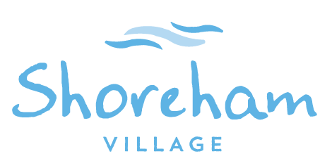
Change Management Plan
September 4, 2021

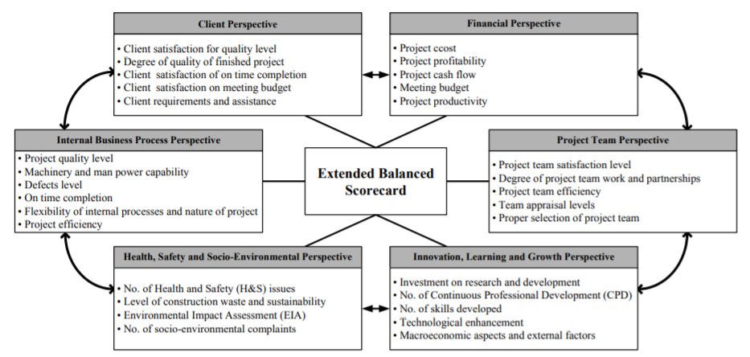
Purpose:
To prepare the Residents, families, Board of Directors and Shoreham Team to successfully transition to the newly renovated infrastructure.
- Engage Shoreham community to share and seek input into the design and functional program
  - Meetings: Resident Council, Family Council, Board Meetings, Communication Meetings, Status Sheets, Staff Meetings
- Engage and share information with the Foundation, Chester Community, Union
  - Community Town Hall, Social Media: Shoreham Website and Facebook
- Address questions and concerns along the way
  - Q & A on Website
- Create a Stakeholder - Building Renewal Team

Phase 1 – Readying
Deliverable | Activity | Documentation | Responsibility
Approval from DHW to begin the process | Announcement of replaced or major renovations | https://novascotia.ca/news/release/?id=20210129004 | DHW
Initial Commitment for funding for Project | Approval to investigate option to rebuild resident living areas | DHW meeting March 3, 2021 | DHW/Northwood Senior Leadership
Develop and Submit Functional Program | Draft is process  Stakeholder Engagement | DHW Template | Project Lead  Northwood Senior Leadership
Approval to Proceed |  |  | DHW
Project Commencement |  |  | Project Lead

Clarify responsibility, role and lead:
- Communication and engagement with DHW
- Communication and engagement with Northwood Leadership
- Communication and engagement with Board
- Communication and engagement Shoreham Team
- Communication and engagement with Stakeholders

Phase 2 – Preparing
Deliverable | Activity | Documentation | Responsibility
Model of Care Impact | Appendix A |  | Shoreham Leadership Team  Josie Ryan
HR Plan | Appendix B |  | Caroline Campbell  Shoreham Leadership Team  Josie Ryan
Resident Transition Plan | Appendix C |  | Shoreham Leadership Team  Josie Ryan
Staff Transition Plan | Appendix D |  | Shoreham Leadership Team  HR Team  Josie Ryan
Licensing Prep | Appendix E |  | Shoreham Leadership Team  Josie Ryan

Phase 3 – Transitioning
Deliverable | Activity | Documentation | Responsibility
Licensing Approval | Appendix E |  | Shoreham Leadership Team  Josie Ryan
Staff Transition and Orientation | Appendix C |  | Caroline Campbell  Shoreham Leadership Team  Josie Ryan
Resident Transition and Orientation | Appendix B |  | Shoreham Leadership Team  Josie Ryan
Licensing Prep | Appendix E |  | Shoreham Leadership Team  Josie Ryan

Phase 4 – Evaluating – Will be important to start right away so we could correct any initial issues as we move into other projects. Maybe a simple tool to provide stakeholders along the way? Looking for a sample tool.

Deliverable | Activity | Documentation | Responsibility
Lessons Learned Report | Appendix F | Evaluations tool  Final Report | Project Lead  Northwood Senior Leadership  Shoreham Leadership Team  Josie Ryan

