Shoreham Village Senior Citizen Association

Update on Strategic Priorities

CEO Report to the Board of Directors
Jan 18, 2023

I hereby confirm that all statutory withholdings and remittances relating to the organization’s employees or otherwise have been made.

1. Strategic Direction: People

Everything we do is for the care and comfort of our residents, the confidence of their family members who trust us and the wellbeing of our staff and volunteers.

Priority 1: Quality of care for our residents and strengthening the long-term care services we provide so that they are sustained to the highest possible standard.

COVID 19- Received notice on January 11, 2023, that the COVID-19 test result of an individual who was recently admitted is positive. The individual does have a roommate and has been up and about in the facility.

We have implemented a number of new (old?) restrictions and are working with Public Health re our screening of other residents.

We continue to have staff who are off work due to exposures or testing COVID-19 positive.

Staffing: We continued to have significant staffing challenges at Shoreham. We do have good days where we have our scheduled staff levels; however, we also have challenging days and continue to rely heavily on temporary staff. Agency staffing for November has been extremely helpful; staff have been getting some vacation. We have received additional staffing from the Provincial Travel Nurse program.

Shoreham Village Foundation- In addition to covering the cost of the heat pump, the Foundation have agreed to include new furniture for E-Wing from in the Golf Tournament marketing and will provide funding based on the golf tournament proceeds. The new fireplace and furniture are now all in place.

Palliative Care- Our new part time Palliative Care nurse has started. We continue to invest in additional program supplies.

Ceiling lifts- Our 3 previously approved (Capital Request Program) lifts have been installed and the additional 10 lifts that we will fund out of operations have been ordered. This will not only support safety for our residents and staff, it will help ease the workload of staff.

Priority 2: The best people are attracted to organizations that have a reputation for being a great place to work. Shoreham Village needs to be a recruitment magnet, which means that all staff experience a deep sense of belonging to an organization that values them.

As of January 6

Position | Hired week of Jan 3 | In Process | Vacancies
PCW/CCA | 0 | 0 | 8 FT / 2 PT
LTCA | 0 | 0 | 2 Casual
LPN | 0 | 0 | Casual
RN | 0 | 0 | 2 FT
FSW/Cook | 1 Cook | 0 | Casual FSW
ESW | 0 | 0 | Casual
Other | 0 | 0 | 2 OTA/PTA Term

CCA Program- Eastern College- Shoreham will be hosting a Western Zone CCA program in collaboration with other long term care facilities in the area and in partnership with Eastern College. The skills lab will be located at Shoreham.

Recruitment- We have brought in additional resources in other areas to help offset the vacancies. For example, we have hired an individual who has multiple skills in the kitchen, inventory review, audits, cooking and menu planning. This will help the Dietary team get caught up. This will be a 4 month term position. We have hired an additional, one year term, admin support person to assist with recruitment and accreditation prep. We have begun to implement a signing bonus to assist with recruitment. We explored a retention bonus for staff but we are prevented from doing so in this environment where our collective agreement has expired and negotiations will be commencing. Hopefully we will be able to reexamine this opportunity later in the fiscal year. We have additional support assisting with interviews.

Two of the key issues that are identified by candidates is housing and transportation:
- Housing- we are in the process of finalizing a second 4 bedroom house of $1,600/ month. We already have 3 international recruits that could utilize 3 of the spaces and having a 4th spot available will assist us in our recruitment efforts. We continue to explore other housing options.
- Transportation- As per the electronic vote of the Board concluded on Dec 11, 2022, we have purchased a Chevy trailblazer. The vehicle has been added to the existing Shoreham Village automobile policy

The insurance requirements are as follows:
- driver abstracts should be obtained for all drivers to ensure that there are no significant events in the history of the drivers.
- A list of main drivers (maximum of 3) should be maintained and updated when changes occur.

The team has established protocols and the vehicle is currently in use.

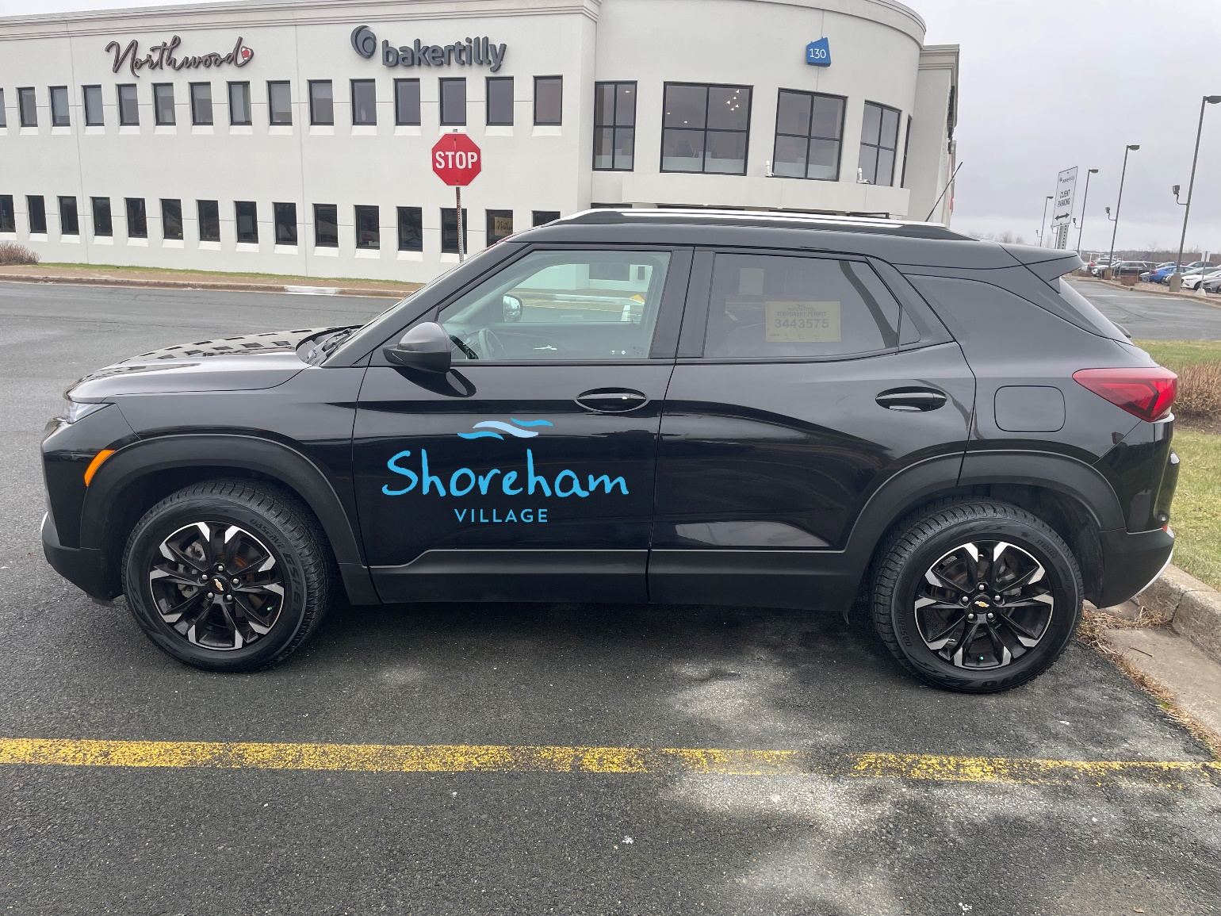

Priority 3: Shoreham Village is fortunate to have dedicated employees, and we want to keep them. Providing a safe and supportive workplace, creating a team environment, creating pathways for progressive career development and demonstrating that we value the dedication of our employees is vital to our retention strategy. We want to be an employer of choice in the community, and in the Continuing Care Sector.

Physician and NP support- Access to Physicians to support LTC across the province is a challenge. We currently have allocated 2 days per week for the NP to provide primary care. We submitted a proposal to primary care for ongoing funding support for this role. They have referred us to the Nova Scotia Health Authority, Primary Care Team to discuss our challenges and our proposal. They did not support funding for our NP position. Dr Clarke has agreed to continue to be the Medical Director for Shoreham and we will continue with the shared NP model with Northwood, which has served us very well.

Staff survey result highlights:
- Good response rate- just under 40%
- Overall sentiment- over 70% positive
- Recruitment and retention/stress burnout/over worked key messages
- Psychological wellbeing also concerning
- However lots of positive feedback as well
Similar to our previous surveys. In 4 of the categories we would be rated as exemplary. An Action Plan to respond to the results is under development. One of the key initiatives will be to get caught up on our performance feedback.

2. Strategic Direction: Places

Our tag line is A Campus for Living. Our campus is shared by our partners who deliver affordable housing services to our community and the Health Centre (OHC). The Campus is a home for the residents who live in our long-term care facility and the tenants who live in the apartments, a workplace for our employees and volunteers and a resource hub for the community. To fulfill this mandate, we will work collaboratively with our partners to design and maintain our buildings, grounds and services to achieve the highest standards and maximum value for those who live, work and meet here.

Priority 1: Over the next five years, a major focus will be on the capital redevelopment of the current structure working with government as it fulfills its commitment to make the necessary investment to bring our facilities up to modern standards of safety and comfort.

Well Water- Noticed a change in usage since early November-not making enough to keep up with the demand. We have had to supplement with 2 loads of water. Rockingham has made an assessment. We are evaluating solutions. We may need to make a capital request for a new well.

Building Renewal Project- As communicated, we were advised by Rick Casavant, Chair of the Shoreham Village Senior Citizens Apartment Association that:
At the Special Meeting of the Shoreham Village Senior Citizens Apartment Association, January 6, 2023, the members voted to Trade/Sell the subject land to the Shoreham LTC. We will approach our mortgage company reference a partial release for the land associated with their mortgage holdings.
We will prepare our report re site options for government to consider reflecting our desired approach and the alternate locations that have been deemed feasible in our investigations.

Strategic Direction: Performance

Shoreham Village strives for excellence in all we do and will continue to build its reputation as a leader in the Continuing Care sector. The management agreement we have in place with Northwood Care, Inc. has proven to be fundamental to our success and we see a strong future for both organizations if we continue on this shared path.

Priority 1: Shoreham Village will participate in the national Accreditation process with the goal of meeting or exceeding all the standards set out.

Scorecard- The 2022/23 Q3 is attached.

Department of Seniors and Long Term Care Standards - Our LTC Advisor visited Shoreham on Dec 7th. She’s been here before as part of her past role as a licensing inspector but this visit brings her to us as our LTC advisor. She was interested in hearing from the team re what is going well and what our challenges are and looks forward to seeing the newly renovated rooms.

Priority 2: Shoreham Village entered into an innovative relationship in 2016 through the development of a management agreement model with Northwood Inc. On the strength of our experience, we believe there is much to be learned from this model and that it has the potential to benefit other organizations within and outside the Continuing Care sector.

Nova Scotia Health Partnership Evaluation: No update.

Priority 3: Partner with other service delivery organizations focused on the needs of the elderly and disabled in the Shoreham Village catchment area. Advocate and support for affordable housing and supports for assisted living.

Projecting Fun for All Project –We have applied for an Age Friendly Grant in the amount of $23,851 for the Recreation department to purchase, install and launch an Omi Vista Mobii Plus for use by residents and as a means to encourage intergenerational programming with the greater community. We have an existing space that is well suited to the installation of the Om Mobii projection system. Adding in the Omi Mobii Plus will enhance the quality of life of residents by introducing visual and sensory stimulation, as well as providing individualized levels of physical movement. It is suitable for all ages and abilities, so we intend to expand beyond resident use to invite community members into our facility for OmiMobii Plus programming.
Shoreham Drummers- The Western - Lunenburg County CHB supported our application for Shoreham Drummers and have provided us with $ 1050.00
New and improved hand wax therapy program, men’s programs and additional haircuts for everyone- We received another generous donation from Sandy Morash. She raised an additional $1200 to assist with these resident amenities. For Christmas each resident received a gift certificate to receive the hair cut of their choice- colour, perm, trim etc; whatever it may be. She will be working towards a new fund raiser where she would like to give our residents a “Ho down” or “Kitchen Party”.
She has been absolutely, wonderfully amazing.

Risk Report

1. Corporate Risk

a. Compliance Risk- Contagious Disease Exclusion Endorsement- The temporary Provincial self-insurance program has been extended for two years, effective November 15, 2022. The two-year period, with the option for government to re-evaluate at any time, provides flexibility to monitor the insurance market for changes related to communicable disease coverage and continue to explore alternative provider options.

2. Service Delivery Risk
a. COVID- 19- At the time of report Preparation (Nov 10, 2022) we had 0 active resident cases.
b. A report of suspected abuse was reported and investigated. We have a number of required follow up items. An Action Plan has been submitted to the PPCA investigator.
Risk Report Legend:
1. Corporate Risk: Strategic, Compliance, Financial, Operational and/or Reputational Risk
Compliance Risk: The threat posed to an organization’s financial, organizational, or reputational standing resulting from violations of laws, regulations, codes of conduct, or organizational standards of practice (Deloitte, 2015).
Financial Risk: The risk of financial loss to the organization’s ability to earn, raise or access capital, as well as costs associated with its transfer of risk. This includes effectiveness of financial processes for reporting, budgeting, funding allocation and fiscal stewardship (North Simcoe Muskoka LHIN, 2010).
Operational Risk: The risk of direct or indirect loss or inability to provide care services, especially to stakeholders, resulting from inadequate or failed internal processes, people and systems or from external events. Operational risks involve factors such as technical or equipment malfunctions and human error, lack of prioritization, management support or expertise, etc. (North Simcoe Muskoka LHIN, 2010).
Reputational Risk: The risk of significant negative public opinion that results in a critical loss of confidence (patient, staff, physician, family, public). The risk may involve actions that create a lasting negative image of, or loss of confidence in, the overall operations of the organization (North Simcoe Muskoka LHIN, 2010).
Strategic Risk: Risks that affect the entire organization and its long-term objectives and are normally managed by the Board of Directors and Executive Team (HealthcareCAN (2016).
2. Service Delivery Risk: This includes, but is not limited to any event that meets the definition of a Harmful Patient Safety Incident (Accreditation Canada, 2017), a Critical Incident as defined by the Department of Health and Wellness or a Serious Workplace Incident, Injury or Fatality as defined in the Occupational Health and Safety Act.

Harmful Incident: A patient safety incident that resulted in harm to the client. Replaces adverse event and sentinel event (Accreditation Canada, 2017a).

Critical Incident: A serious event affecting either the resident (client), staff or the public (Province of Nova Scotia, 2015).

Serious Workplace Incident: An incident such as the following: an accidental explosion, major structural failure, major release of a hazardous substance, a fall from a work area where fall protection is required by regulations (Province of Nova Scotia, 2017).

Serious Workplace Injury: an injury that endangers life or causes permanent injury, such as, loss of limb, third-degree burn, any injury that requires admission to a hospital (Province of Nova Scotia, 2017).

Respectfully submitted,
Janet Simm
Chief Executive Officer
Shoreham Village Senior Citizen Association

