Shoreham Village Senior Citizen Association

Update on Strategic Priorities

CEO Report to the Board of Directors
Jan 17, 2024

I hereby confirm that all statutory withholdings and remittances relating to the organization’s employees or otherwise have been made.

1. Strategic Direction: People

Everything we do is for the care and comfort of our residents, the confidence of their family members who trust us and the wellbeing of our staff and volunteers.

Priority 1: Quality of care for our residents and strengthening the long-term care services we provide so that they are sustained to the highest possible standard.

COVID 19/Infection Control - At the time of report preparation (Jan 11, 2024) we have one active resident case. We continue to have staff who are off work due to exposures or testing COVID-19 positive.

Resident Council - A Resident Council meeting was held Nov 15 and Dec 20, 2023. The discussion included follow up on previously expressed concerns, ongoing COVID-19 precautions, access to the NP, water concerns, a small flood on A-wing and menu. There was a discussion surrounding that Shoreham is the residents home and the staff are working in their home. Requesting that staff be regularly reminded of that.

Family Council- A meeting was held on Nov 28, 2023. Topics discussed included:
- Mat leave coverage for physio
- Exercise programs for residents
- Water issues and use of disposable dishes
- The new means of family communication via an EHR tool
- Electrical equipment and furniture policy updates and changes
- Accreditation success and review of unmets
- Bus repair completion
- Holiday schedule
- Process for families and residents to be engaged in policy development and review
- New building update and the plan for a consultation session.

Please note that Abby Clarke Casely has left Northwood to join the IWK. We welcome Meghan Murchison to that role. The next meeting is tentatively scheduled for Tuesday March 5, 2024.

Leadership Team- We have welcomed Shannon Corkum and Emily Johnston-Smith as our newest Nursing Services Managers at Shoreham Village. Shannon began on Dec 10th and Emily began on Jan 2nd. Prior to this, both have been working at Shoreham in the Nursing department. They spent some time during their orientation for Manager specific orientation at the Northwood Bedford Campus.

Collective Bargaining- On Dec 18, 2023, tentative 5-year deal with NSNU was reached. This agreement will cover approximately 40 LTC facilities in the province. Northwood’s HR team were members of the lead table for the negotiations.

Bus- Repairs have been completed.

Priority 2: The best people are attracted to organizations that have a reputation for being a great place to work. Shoreham Village needs to be a recruitment magnet, which means that all staff experience a deep sense of belonging to an organization that values them.

Staff Housing: We currently have 3 homes that we are leasing that are fully utilized. We have the majority of the rental costs covered by staff using those accommodations. We continue to work on strategies to reduce any expense we are incurring while balancing the needs for affordable/quality housing for new staff coming to the area.

International Recruitment- On Dec 20, we welcomed another newcomer to Shoreham Village. He was greeted at the airport late night by the Northwood Team, and the Shoreham Village team picked him up and supported his orientation to the community, and his new home the following day. The picture shows him arriving and his gift of a new coat hat and mittens!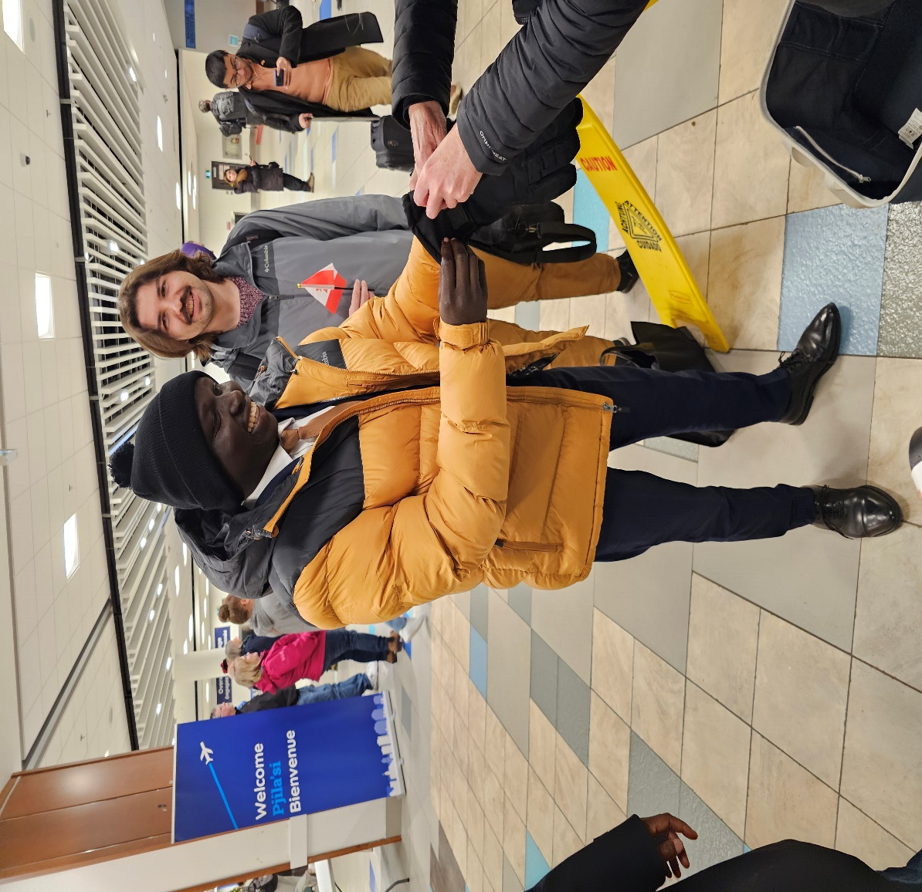

Priority 3: Shoreham Village is fortunate to have dedicated employees, and we want to keep them. Providing a safe and supportive workplace, creating a team environment, creating pathways for progressive career development and demonstrating that we value the dedication of our employees is vital to our retention strategy. We want to be an employer of choice in the community, and in the Continuing Care Sector.

No Update

2. Strategic Direction: Places

Our tag line is A Campus for Living. Our campus is shared by our partners who deliver affordable housing services to our community and the Health Centre (OHC). The Campus is a home for the residents who live in our long-term care facility and the tenants who live in the apartments, a workplace for our employees and volunteers and a resource hub for the community. To fulfill this mandate, we will work collaboratively with our partners to design and maintain our buildings, grounds and services to achieve the highest standards and maximum value for those who live, work and meet here.

Priority 1: Over the next five years, a major focus will be on the capital redevelopment of the current structure working with government as it fulfills its commitment to make the necessary investment to bring our facilities up to modern standards of safety and comfort.

Building Renewal Project: On November 7, 2023, Step 5 of the FDAP process was submitted to the Department of Seniors and Long Term care. We have submitted responses to our inquiries on our Step 4/5 submission on January 10, 2024. The inquiries were regarding budget and timelines. The land swap agreement is progressing. We are preparing to submit a large portion of the Step 6 items to the Department of Seniors and Long Term Care this month. We will target mid March for the community consultation. Please see attached the first draft of the event plan for feedback.

Water- Work to connect our new well (#7) to our existing building is nearing completion. We anticipate it will be connected by January 15, 2024. Then we can evaluate water production. We hope we will be able to cease bringing in truckloads of water costing us approximately $1000 per week. We hope to meet with the Apartment Association once we have finalized that work and have an opportunity to evaluate how well the new well performs.

Strategic Direction: Performance

Shoreham Village strives for excellence in all we do and will continue to build its reputation as a leader in the Continuing Care sector. The management agreement we have in place with Northwood Care, Inc. has proven to be fundamental to our success and we see a strong future for both organizations if we continue on this shared path.

Priority 1: Shoreham Village will participate in the national Accreditation process with the goal of meeting or exceeding all the standards set out.

We met 5/288 of the national accreditation standards and met all of the Required Organizational Practices. There is an action plan to address the remaining 5 standards and other suggestions for improvement are underway.

Priority 2: Shoreham Village entered into an innovative relationship in 2016 through the development of a management agreement model with Northwood Inc. On the strength of our experience, we believe there is much to be learned from this model and that it has the potential to benefit other organizations within and outside the Continuing Care sector.

Nova Scotia Health Partnership Evaluation- No further progress has been made.

Department of Seniors and Long Term Care- Our service agreement is up for renewal (industry wide). Meetings are being established in February to discuss the updated requirements and new expectations. The impact from the Protected and Unprotected funding model will be a priority discussion item for us.

Priority 3: Partner with other service delivery organizations focused on the needs of the elderly and disabled in the Shoreham Village catchment area. Advocate and support for affordable housing and supports for assisted living.

Our Rec Department request for a Recreation Grant was considered by the Municipality of Chester on November 16 and was approved in the amount of $1500.00.

Risk Report

1. Corporate Risk

a. Compliance Risk- Contagious Disease Exclusion Endorsement- Since March 2020, many long-term care facilities have had coverage for communicable diseases removed from their liability insurance by their insurers upon renewal. On March 15, 2022, a temporary provincial self-insurance program for secondary communicable disease liability coverage (self-insurance program) for Continuing Care and Community Services Providers was approved while alternative options were explored. The self-insurance program will expire on November 15, 2024. The self-insurance program was implemented to provide the time needed to monitor the insurance market for changes related to communicable disease coverage and to continue supporting the sector in seeking alternative options. Communicable disease coverage is now being offered by some insurance companies on standalone policies; however, this is a new product and there are very few insurers offering the coverage. To further assist the sector in securing coverage, The Department of Seniors and Long-Term Care (SLTC) requires an update on the current state of insurance coverage in the sector to better inform options before the temporary self-insurance program expires. We have been requested to respond to another survey due January 10, 2024

2. Service Delivery Risk
a. COVID- 19- At the time of report Preparation (Nov 9, 2023) we had 1 active resident cases.
b. Harmful Incident- As reported on September 28, 2023, an individual who was using our respite bed had a fall which unfortunately resulted in a fractured hip. The incident was filed as a critical incident to the Department of Seniors and Long Term care. They had asked for a 30-day follow-up, which was completed and the incident is now closed. The individual is in hospital post-surgery awaiting for LTC placement. On October 30,2023, the CEO reached out to the family offering an apology and providing our investigative findings and corrective action plans. We have not heard from the family since then.

c. Harmful Incident- Our Action Plan responding to the incident involving the security guard (PPC File #: SHOR-2023-17) was submitted on Dec 5, 2023.

Risk Report Legend:
1. Corporate Risk: Strategic, Compliance, Financial, Operational and/or Reputational Risk
Compliance Risk: The threat posed to an organization’s financial, organizational, or reputational standing resulting from violations of laws, regulations, codes of conduct, or organizational standards of practice (Deloitte, 2015).
Financial Risk: The risk of financial loss to the organization’s ability to earn, raise or access capital, as well as costs associated with its transfer of risk. This includes effectiveness of financial processes for reporting, budgeting, funding allocation and fiscal stewardship (North Simcoe Muskoka LHIN, 2010).
Operational Risk: The risk of direct or indirect loss or inability to provide care services, especially to stakeholders, resulting from inadequate or failed internal processes, people and systems or from external events. Operational risks involve factors such as technical or equipment malfunctions and human error, lack of prioritization, management support or expertise, etc. (North Simcoe Muskoka LHIN, 2010).
Reputational Risk: The risk of significant negative public opinion that results in a critical loss of confidence (patient, staff, physician, family, public). The risk may involve actions that create a lasting negative image of, or loss of confidence in, the overall operations of the organization (North Simcoe Muskoka LHIN, 2010).
Strategic Risk: Risks that affect the entire organization and its long-term objectives and are normally managed by the Board of Directors and Executive Team (HealthcareCAN (2016).
2. Service Delivery Risk: This includes, but is not limited to any event that meets the definition of a Harmful Patient Safety Incident (Accreditation Canada, 2017), a Critical Incident as defined by the Department of Health and Wellness or a Serious Workplace Incident, Injury or Fatality as defined in the Occupational Health and Safety Act.

Harmful Incident: A patient safety incident that resulted in harm to the client. Replaces adverse event and sentinel event (Accreditation Canada, 2017a).

Critical Incident: A serious event affecting either the resident (client), staff or the public (Province of Nova Scotia, 2015).

Serious Workplace Incident: An incident such as the following: an accidental explosion, major structural failure, major release of a hazardous substance, a fall from a work area where fall protection is required by regulations (Province of Nova Scotia, 2017).

Serious Workplace Injury: an injury that endangers life or causes permanent injury, such as, loss of limb, third-degree burn, any injury that requires admission to a hospital (Province of Nova Scotia, 2017).

