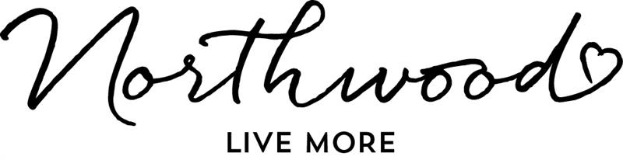
SELF-IDENTIFICATION QUESTIONNAIRE
INTRODUCTION
Northwood is committed to fostering a diverse, inclusive, and equitable Board of Governors that reflects the communities we serve. This questionnaire supports our transparent and equitable process for Board member selection, renewal, and succession planning, ensuring our membership reflects diverse perspectives. This commitment supports our obligations under Accreditation Canada standards on governance effectiveness, cultural safety, and addressing systemic racism, including Indigenous-specific systemic racism.
To achieve these goals, we collect voluntary self-identification information from Board members. The information you provide will:
- Be used in aggregate form to review and enhance Board composition and effectiveness.
- Inform our diversity action plans, including commitments to cultural safety, anti-racism, and Indigenous reconciliation.
Your participation is encouraged, but voluntary. You may choose not to answer any question, and you may select more than one response where applicable. You may update or correct your information at any time.
All responses are confidential. Individual information will not be shared publicly and will be used solely for statistical reporting purposes. Definitions in this questionnaire are aligned with the Employment Equity Act, Statistics Canada categories, and related best-practice guidelines.
SECTION 1: GENDER IDENTITY
Definition: Gender identity refers to a person’s internal and individual experience of gender, which may or may not align with the sex assigned at birth.
Question: Please specify your gender identity: ________________________________
- Prefer not to answer
SECTION 2: SEXUAL ORIENTATION
Definition: Sexual orientation refers to a person’s emotional, romantic, or sexual attraction to others.
Question: Please specify your sexual orientation: _______________________________
- Prefer not to answer
SECTION 3: PERSONS WITH DISABILITIES
Definition: A disability is a long-term or recurring physical, mental, sensory, psychiatric, cognitive, or learning condition that may affect daily activities and may require accommodation.
The Accessible Canada Act defines disability as “any impairment, including a physical, mental, intellectual, cognitive, learning, communication or sensory impairment – or a functional limitation – whether permanent, temporary, or episodic in nature, or evident or not, that, in interaction with a barrier, hinders a person’s full and equal participation in society.” Do you identify as a person with a disability as described in the Act?
- Yes
- No
- Prefer not to answer
Please indicate if you would benefit from support.
SECTION 4: INDIGENOUS IDENTITY
Definition: Indigenous peoples in Canada are the original inhabitants of the land, comprising First Nations, Métis, and Inuit.
Question: Do you identify as an Indigenous person?
- Yes
- No
- Prefer not to answer
- If yes, select all that apply to you.
- First Nations – Descendants of the original inhabitants of Canada who identify as First Nations (Status or Non-Status).
- Métis – A person who identifies as Métis, a distinct Indigenous people with mixed First Nations and European ancestry, and who is recognized as such by their community.
- Inuit – A person who identifies as Inuit, the Indigenous people of the Arctic regions of Canada.
- Not listed above, please specify
- Prefer not to answer

SECTION 5: VISIBLE MINORITY IDENTITY

The Employment Equity Act defines visible minorities as “persons, other than Aboriginal peoples, who are non-Caucasian in race or non-white in colour.”
The term “racialized” is a more current term than “visible minority” from the Employment Equity Act.
Do you identify as a racialized person?
- Yes
- No
- Prefer not to answer

Do you identify as a racialized person? If so, please provide details if you wish to share.

- Yes
- No
- Prefer not to answer

Is there anything you want to share about your race, religion, or cultural background?

SECTION 6: AGE GROUP
Age categories are collected to support diversity in generational perspectives and representation on the Board.
Question: Please select the age range that applies to you:
- Under 35
- 35–49
- 50–64
- 65+
- Prefer not to answer

SECTION 7: LANGUAGE
Language information is collected to better understand the linguistic diversity of the Board and to support inclusivity in governance discussions.
Question: What is your primary language of comfort for communication?
- English
- French
- Mi’kmaq
- Other Indigenous language (please specify)
- Other (please specify)
- Prefer not to answer

SECTION 8: ADDITIONAL COMMENTS
(Please share anything else you believe is important regarding your lived experience, identity, or perspectives)

